

**TITLE OF THE PROJECT:**

**MARKETING WEBSITE**

|  |  |  |  |
| --- | --- | --- | --- |
| **S.no** | **Registration no.** | **Name** | **Roll no.** |
| 1. | 11904533 | Aditya Tiwari | 31 |
| 2. | 11902474 | Yeldhurthi Manas | 32 |
| 3. | 11902247 | Astha Singh | 10 |
| 4. | 11902305 | Kunhimma Sharoon | 33 |

**INTRODUCTION**

**Websites:**

A website is a group of web pages that have information in the various pages that contain similar subject materials. For instance, the web site would have a name (subject) such as GoodFords.com and have several pages related to good Ford vehicles. The website has a main web page commonly called the Homepage (index.html or default.html). The site's address will display the homepage and you can click on hyperlinks to go to other pages on the website.

A webpage is a text page written in a form of HTML (hyper text markup language) that contains text, links or tags that will display graphics, audio, video, downloadable files and of course other web pages.

**Marketing website:**

Every successful marketer has a web presence including a business domain name hosted at a reputable hosting company. As a matter of fact, most marketers have several domain names for the many different companies that they are actively marketing. Web marketing also referred to as online marketing has created now an important atmosphere to market the offerings of companies through the web and its applications. Internet marketing ties together the creative and technical aspects of the Internet, including design, development, advertising and sales. Internet marketing also refers to the placement of media along many different stages of the customer engagement cycle through search engine marketing (SEM), search engine optimization (SEO), banner ads on specific websites, email marketing, mobile advertising, and Web strategies.

There are many objectives for marketing websites like:

* *Building or Introducing a brand:*

Internet marketing objectives often include building a brand. This means not only establishing your logo and company name in the minds of consumers, but also what your company stands for well-known brands are typically trusted more by customers, especially when paired with positive associations. The Internet is a great tool for building that trust, because it has a wide reach and allows you to directly connect with individuals.

* *Increase revenue:*

The primary goal of any marketing strategy is ultimately to increase revenue, and Internet marketing is no exception. Thankfully, the Internet provides plenty of opportunities for every business to improve their bottom line. By combining search engine optimization, or SEO, with pay-per-click ads, or PPC, your company can improve the chances that potential customers find online. And with strategies like content marketing and social media marketing, we can position yourself as an expert in your field who also cares about the clients.

* *Manage Online Reputation:*

In an age when anyone with a computer or smartphone can post their opinions about companies, products, and services for the whole world to see, it’s important for businesses to maintain a solid online reputation. This means monitoring your company’s name, done maintaining social profiles, and responding to bad accordingly. One bad review doesn’t mean that your company’s reputation is shot, but one bad reaction to a bad review might. The way you publicly respond to customer complaints will show them (and all other current and potential customers) how much you care about.

**DIAGRAM OF THE MARKETING WEBSITE**



**FLOWCHART OF MARKETING WEBSITES**

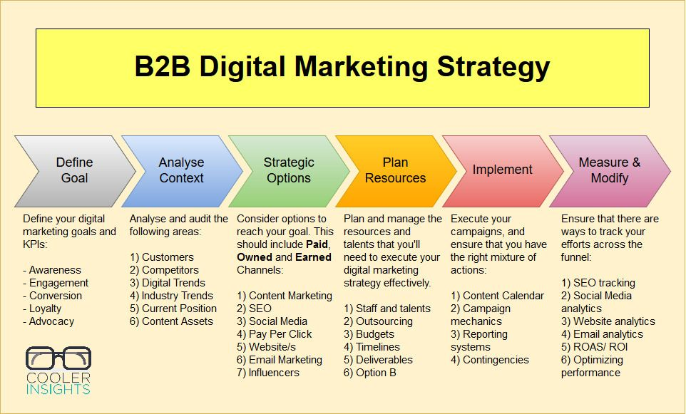

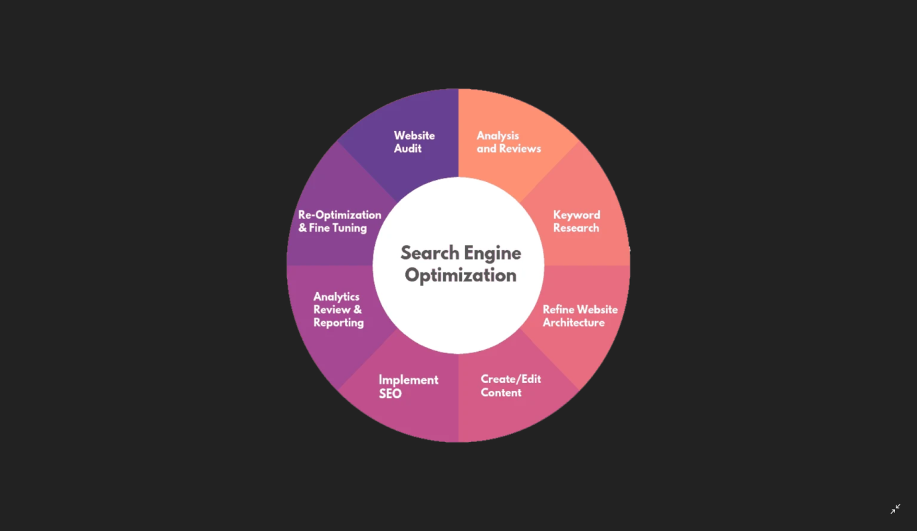

**DATA FLOW DIAGRAM OF MARKETING WEBSITES:**

***Zero level DFD of Maketing strategy:***

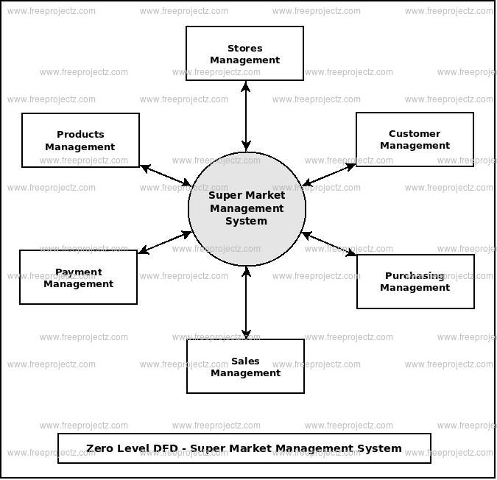

***First level of DFD of marketing strategy:***

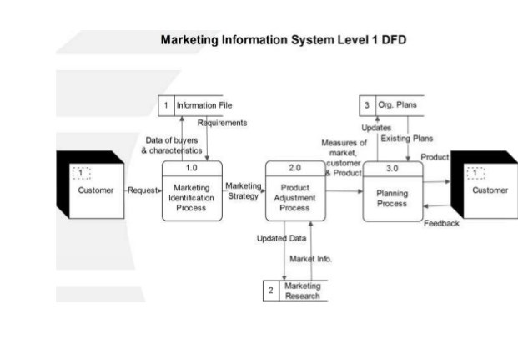

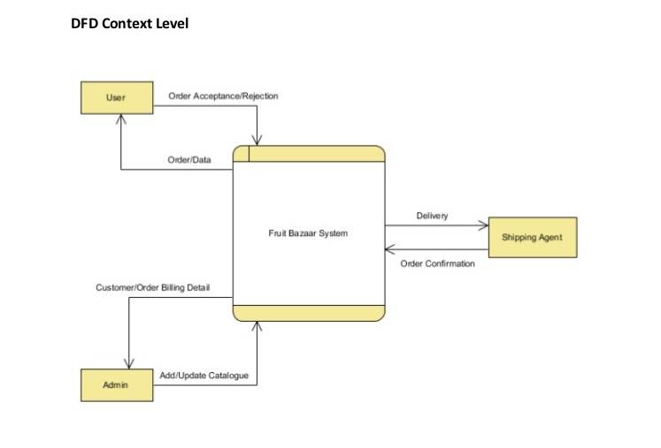

**DESCRIPTION OF THE PROJECT**

We are preparing the marketing website by using HTML ,CSS and java. Project had divided into three parts among the group members.

Firstly we had gathered the information about marketing websites and also there startegies. And we started coding the marketing website via html, java and css.

My group member Aditya have done the html design, Astha used the java script code for implementation of website, Manas had done css styling for website and K.Sharoon made the webpage outlay.

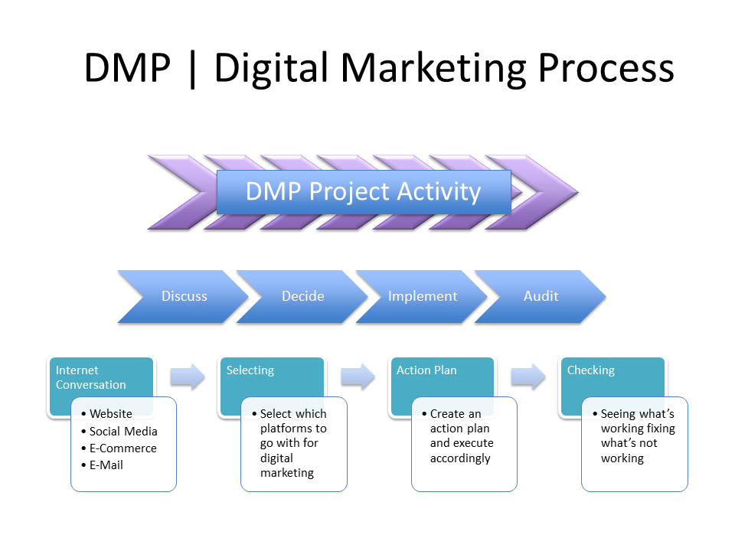

**SECTION WISE EXPLAINATION OF WEBSITE**

This is the top of our webpage layout in which we use image tag (<image></image>) to put that marketing picture and for the menus in the top right section we us button tag (<button type=“button”></button) . Now we style the navigation bar with css by giving padding, by giving colour and we also apply “hover” when the menu is slide down. We also use “sticky” property whit navigation bar.

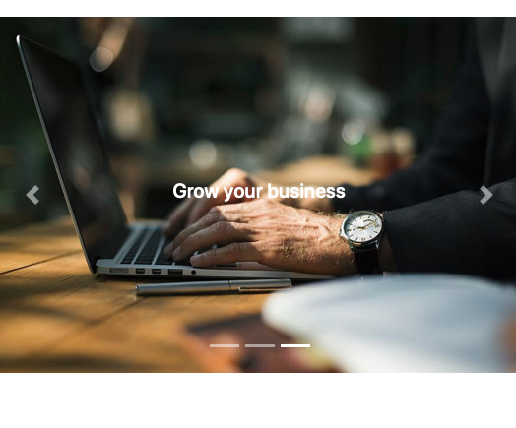

We use this image in our website with the help of image tag we apply 3 different images which slides after some time and we also use css styling to style this image format like we use padding , border ,we use transparency property to make image transparent because we have to write some information to the image (as you can see) and we also use java script for the sliding of image like we use sliding function and input and for giving the time in between the scroll of each image etc.

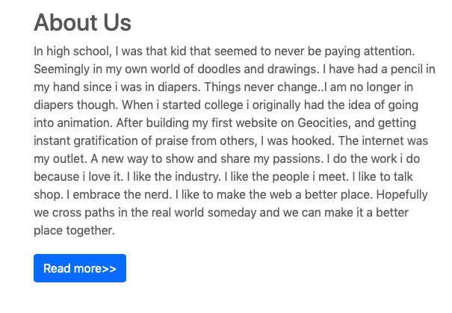

We write this paragraph by using paragraph tag (<p></p>) we also use external css to take it margin from top of 20px and from bottom we use the bottom margin of 30px. We use Button Tag for the button at the bottom we use (<button type=“button”></button>) and give it colour blue by using css.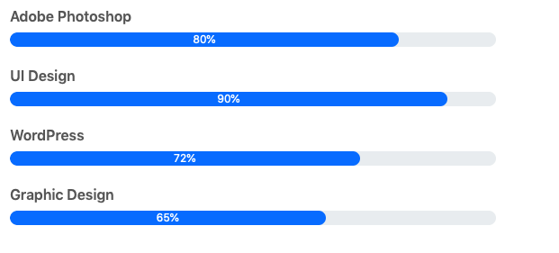

For this we use skill bar technique first we create **“box border”** using css and the we add different entries like adobe photoshop, UI Design, etc then we add width to the box border and resize it the we add colour “**blue**” to it and the by css we use “**border-radius”** command to make border of round shape.

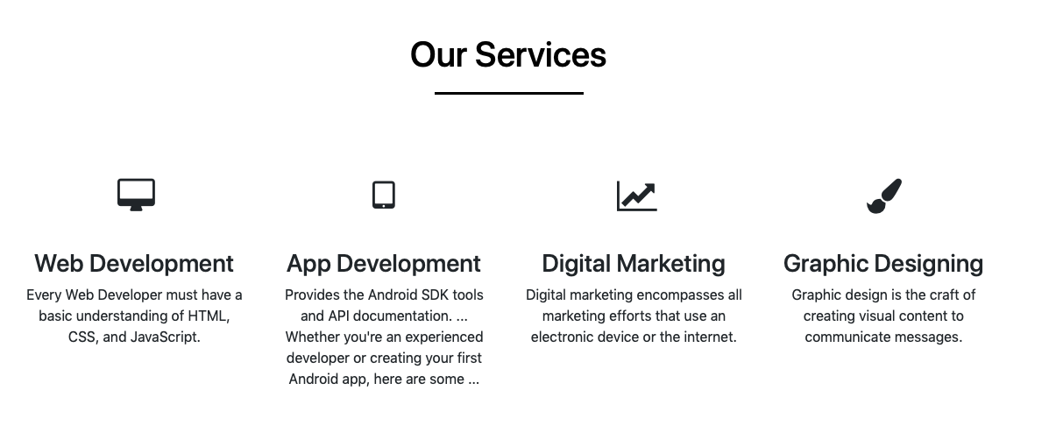

In this we first give heading with the **heading tag** (<h1></h1>) the we give **padding** and **margin** using **css**, the using css we take padding and images for different task then we write its information using **paragraph tag** (<p></p>).We also use **“hover style”** in css so that when we take the mouse in different section we get hover effect.

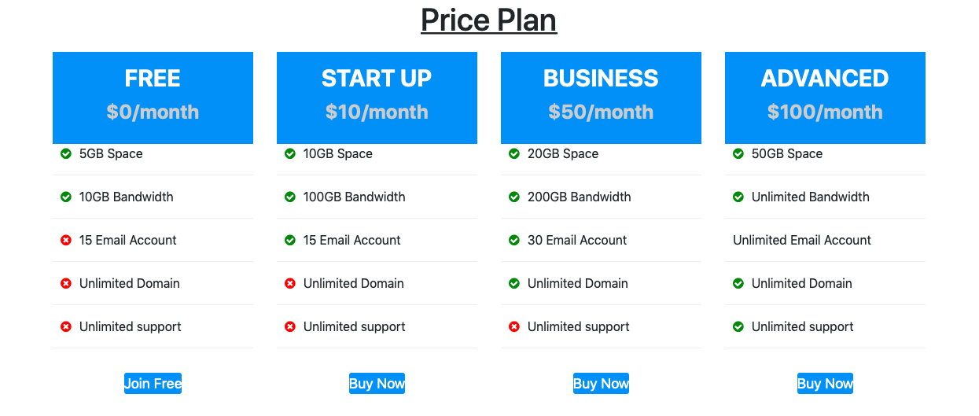

In this we first give heading with **“heading tag”** then for price head we give **background colour** using css and we **align text** we also us **padding** for all price heads.

After that we create an **“unorder list”** using **list tag**, then we put list item with the help of **“check-circle and crossed circle sign”.**

We also use **hover** using css to get **hover effect** in our price plane.

We give **links** in which we use **“href=#”** (e.g. join free, buy now),we provide style to these link by css by giving “**bg color”** ,etc.

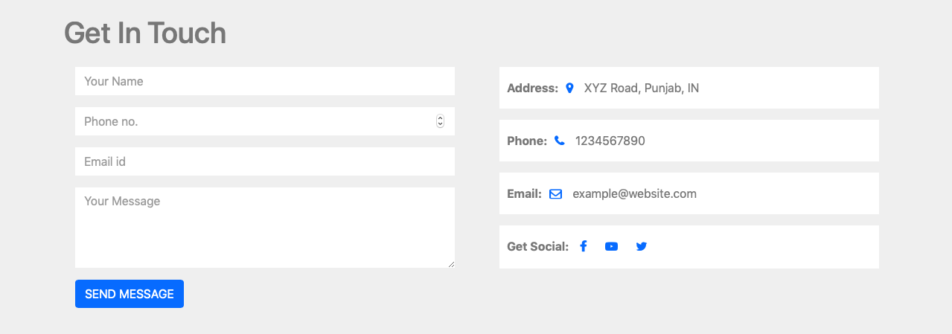

We first give heading by using **heading tag** then we use **form tag** to create this form layout and by using **css** we give style to the form. We use **padding** ,we give **background colour** to this form, we give **border radius** by using **css** and last we give button by **button tag** and attach **href=“#”**,to it.

**Link for explaination for marketing website:**

*https://youtu.be/iDdra8LhdAE*

**SCREENSHOT OF MARKETING WEBSITE:** 